**Lab 1.5**

**Santiago Caldas**

**INET 3101**

**Instructor: Joe Axberg**

**Number of pages:** **4**

1. UsesStaticArray

-

1. MallocPrinter

1. DyanmicAlllocation

* In this case, since a while loop is implemented to be able to reallocate memory infinitely. First, the user is prompted to enter the desired malloc size. Then, if the user wishes to enter more numbers it can do so eternally altering the array size in the heap memory and using a letter as command for ending the loop. Finally, it prints the final values in the array modified.

1. SimpleDynamicExcersice

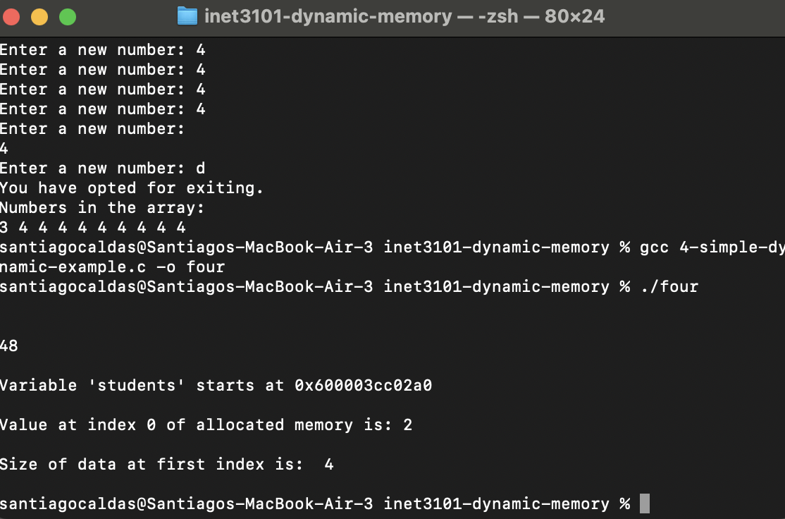

1. PythonLists

**Objects**:

* + An instance of a class that can hold both data (attributes) and methods (functions).
  + Objects represent real-world entities or concepts.

**Benefits of OOP**

* **Reusability**: Through inheritance, existing classes can be reused to create new classes, reducing redundancy.
* **Maintainability**: Changes in one part of the code can be made with minimal impact on other parts, making maintenance easier.
* **Scalability**: OOP systems can be easily expanded as new classes and objects can be added without disrupting existing code.

In summary, object-oriented programming is a powerful paradigm that helps developers create flexible, reusable, and maintainable code.

1. Linkedlist

* In the case of linked lists, they overcome the memory allocation problem by storing a value and arbitrarily assign it into the next one. This is not just helpful to be able to dynamically store values, but it can also serve the purpose of creating a list order,

Linked List: 30 -> 20 -> 10 -> NULL

1. ManagingAllocation

* 1 2 3 4 5 6 7 8 9 10 11 12 13 14 15 16 17 18 19 20 21 22 23 24 25 26 27 28 29 30 31 32 33 34 35 36 37 38 39 40 41 42 43 44 **%**

1. Headers.

* Inserting header of our own is different than using the standard packages, so the methodology for compiling is altered as well.

